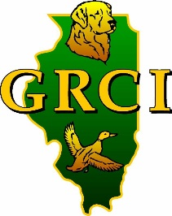
Golden Retriever Club of Illinois—4 Specialties

CONFORMATION Event dates: June 15th & June 16th
Event host: Golden Retriever Club of Illinois
Specialty judges: Friday--Mareth Kipp, Ray Yurick
Saturday--Terry DePietro, Virgina Murray
Event location: Lake County Fairgrounds—Grayslake, IL
GRCI contact: Nolan Ryan—Specialty Chair nryan9444@comcast.net

OBEDIENCE/RALLY Event: 2 All-breed Obedience/Rally Trials in one day—June 16th
Event host: Golden Retriever Club of Illinois
Event Location: Libertyville Sport Complex—Libertyville, IL
Obedience Judges: Loretta Lazarra: Trial I—Utility/Beg Novice A & B
Trial II—Open/ Novice A & B
Fred Buroff: Trial I—Open/Novice A & B
Trial II—Utility/Beg Novice A & B
Rally judge—both trials: Dr. Sandy Gould
GRCI contact: Murray Mitchneck—Obedience Chair mmitchneck@aol.com
GRCI web site: http://www. grcillinois.org/
Closing date: May 30, 2017
Roy Jones Dog Shows

ADDITIONAL COMMENTS
All-Breed Obedience/Rally Trials—North Shore DTC (Sunday, June 17th) same site
*Pending AKC approval

